TASK | Welding Activities
LOCATION OF USE | Factory |  | Assessment  No |  | 029
PRODUCT NAME | Welding Fume emitted from welding activity
DESCRIPTION OF SUBSTANCE | Airborne contaminants created during welding process
MANUFACTURER

MANUFACTURERS CONTACT
ASSESSOR | M Monaghan (Direct Safety Solutions) |  | Date |  | 04 12 25
TITLE |  |  | Review by |  | 04 12 27
Personnel Performing Task  (Please list below)  Trained Operative |  | Time Spent  (Minutes/day)  1hr per day | Training Given 
 |  |  | Yes | 

MSDS Revision Date | Risk Phrases | Safety Phrases

Please denote the hazardous properties of the substances used in the task with a 

INTERNATIONAL GLOBALLY HARMONISED HAZARD SYMBOLS
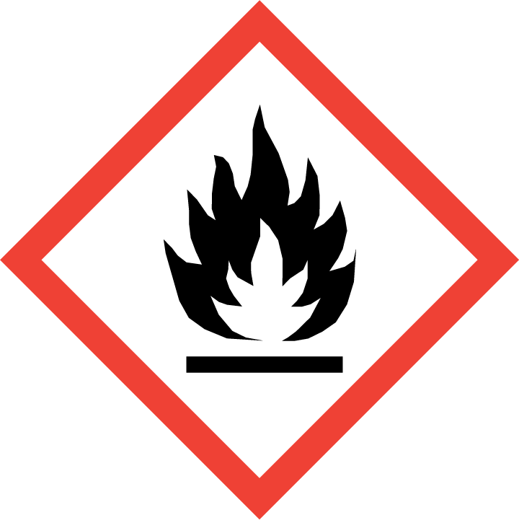 | 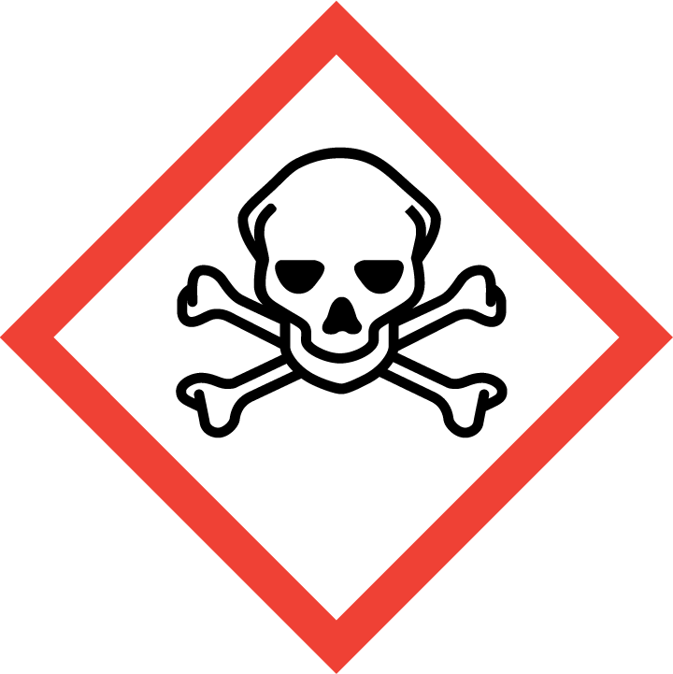 | 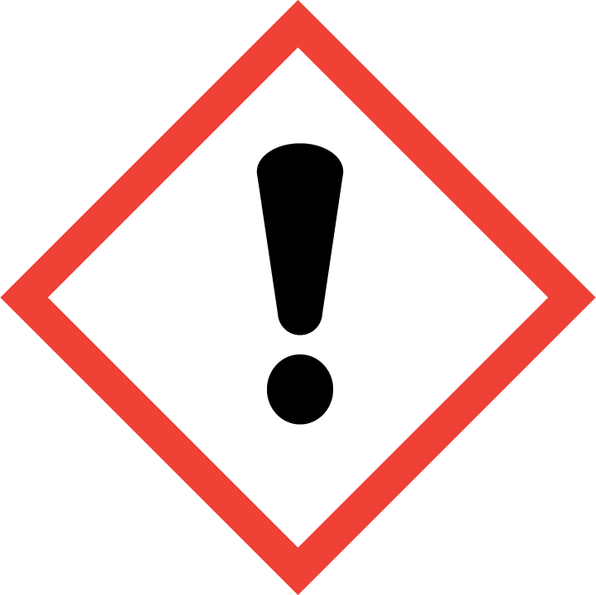 | 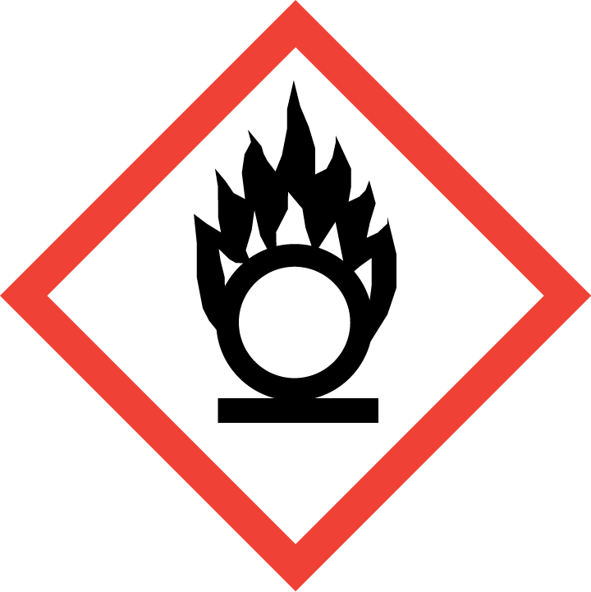 | 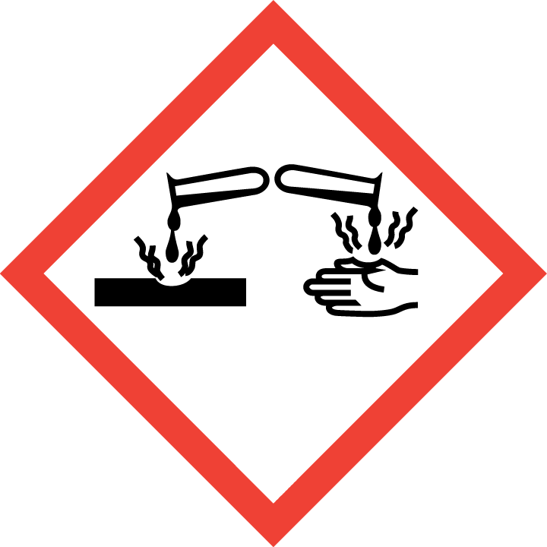 | 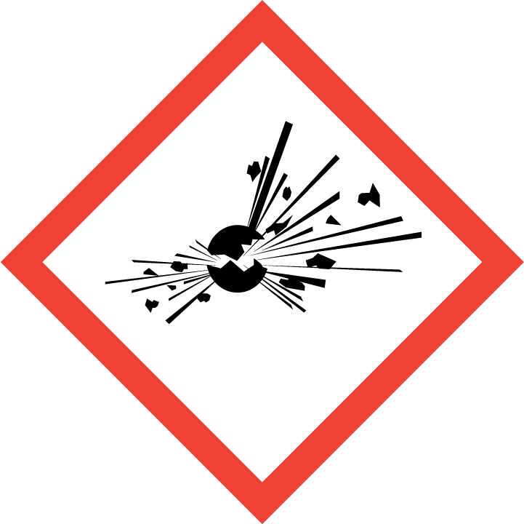 | 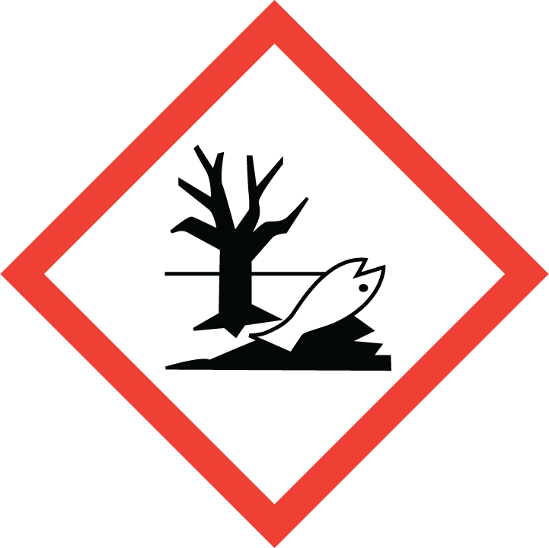 | 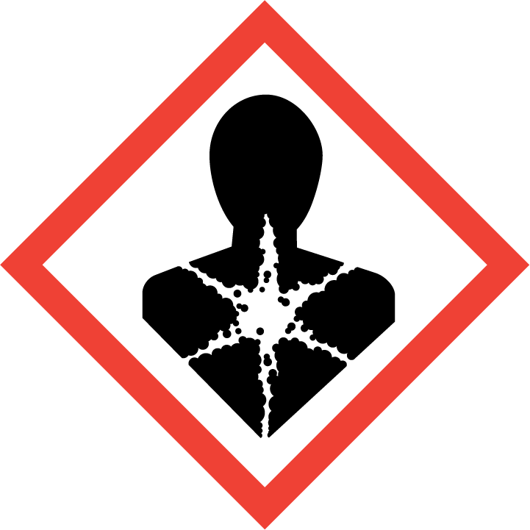
Flammable | Toxic | Harmful | Oxidising | Corrosive | Explosive | Harmful to the environment | Health Hazards i.e. respiratory sensitisation or carcinogenicity
 |  |  |  |  |  |  | 

SMOKING, EATING AND DRINKING ARE PROHIBITED IN THE WORK AREAS.
Information, Instruction and Training must be provided to all users. Young Persons, New or Expectant Mothers and other vulnerable groups must not use or be exposed to this product.

WORKPLACE EXPOSURE LIMITS (WEL’s)
Due to the changing nature of the welded material, surface treatment and type of welding undertaken, the exact composition of the fume is undetermined.
An air monitoring survey will identify the chemical makeup of fume on a particular day.

ROUTE OF EXPOSURE
Skin |  | Eyes |  | Inhalation | 
Ingestion |  | Cuts/abrasions |  | Systemic

PERSONS AT RISK
User of product |  | Co workers |  | Members of the public

ROUTE OF EXPOSURE |   FIRST AID MEASURES
Eyes
Skin
Inhalation | Transport to fresh air
Ingestion
In all cases of doubt, or if symptoms persist seek medical attention. Never give anything by mouth to an unconscious person. If unconscious, place in recovery position and seek medical advice.

PERSONAL PROTECTIVE EQUIPMENT
 |  | 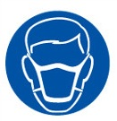 | 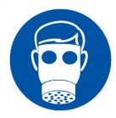 |  | 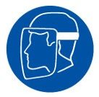
VISOR | OVERALLS | P3 HIGH EFFICIENCY | AIR FED HOODS | GAUNTLETS
 |  |  |  | 
Air monitoring may recommend an air fed helmet.

HANDLING | STORAGE | TRANSPORT | DISPOSAL
N/A | N/A | N/A | Discharged vis LEV to atmosphere.

GENERAL CONTROL MEASURES
THESE ARE PRECAUTIONS AVAILABLE NOW OR AT SHORT NOTICE, WHICH MUST BE IN PLACE TO PROTECT HEALTH & SAFETY PRIOR TO COMMENCING TASKS!
- Competent trained operatives (users) only to carryout welding activities
- Keep the work area clean and free of combustible materials.
- Only allow access to authorised staff
- Work is located in designated bay.
- Confirm that extraction is turned on and working
- Adjust a moveable welding hood so it collects hot fume rising. The hood should be within one duct diameter of the welding point
- Practise good hygiene and ensure adequate welfare and washing facilities available
- Ensure COSHH assessments are made available for all employees and users and for inspection and emergency purposes

FIRE PRECAUTIONS
- Powder extinguishers close to the welding bays

ACCIDENTAL RELEASE/SPILLAGE PROCEDURES
N/A

MONITORING REQUIREMENTS AND HEALTH SURVEILLANCE
An air monitoring survey will provide guidance on the type of health surveillance required.

